Fife u3a June Members Showcase 25-26
Fife u3a returned on June 11th to the successful format started last of year to use the June monthly meeting to highlight group happenings throughout the 2025-6 u3a year. We decided to rename the event June Members Showcase this year and once again included it in the programme for the Lang Toun Fest, a month-long festival events taking place in Kirkcaldy, Fife. A bit free of publicity.
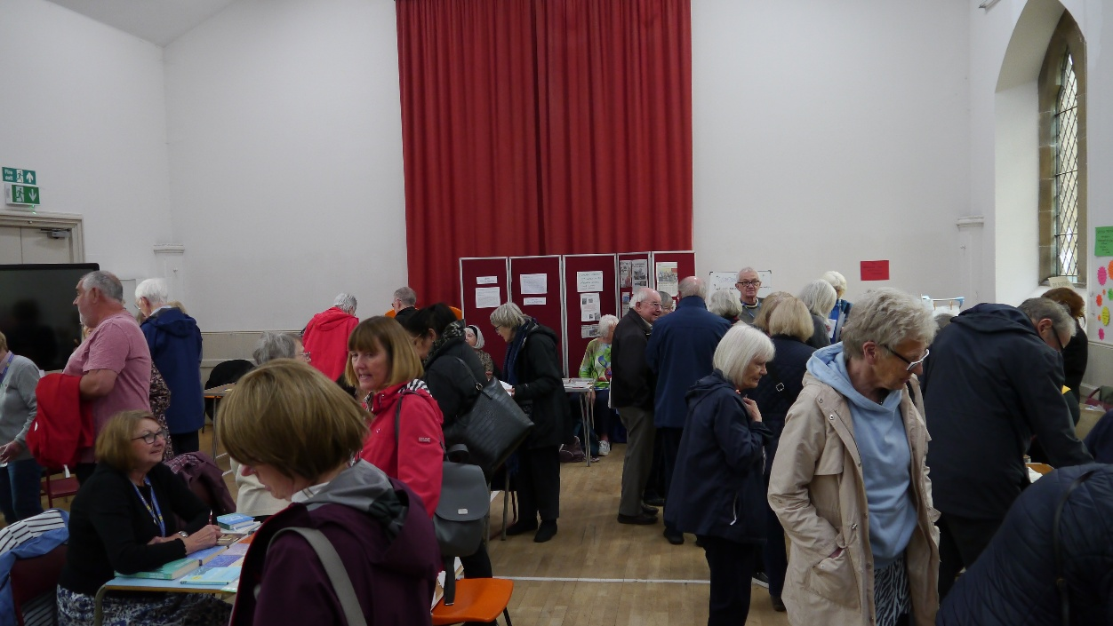
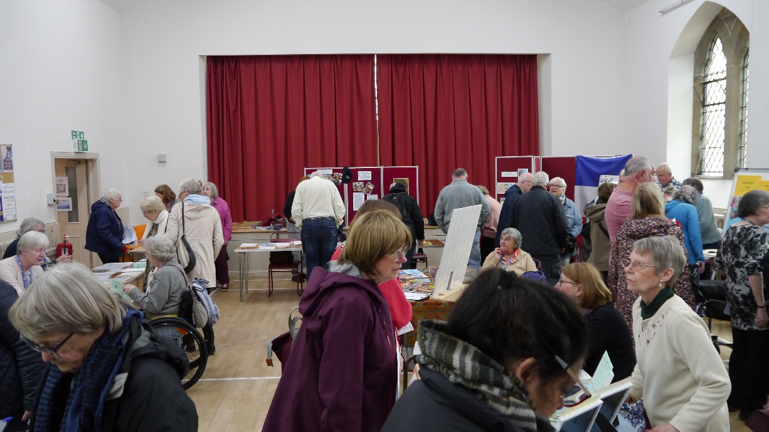

Groups set out their stalls with information about their exploits. It was a great way for members to find out about potential new activities and members of the public to have a taster of what the u3a has to offer. There was very positive feedback.
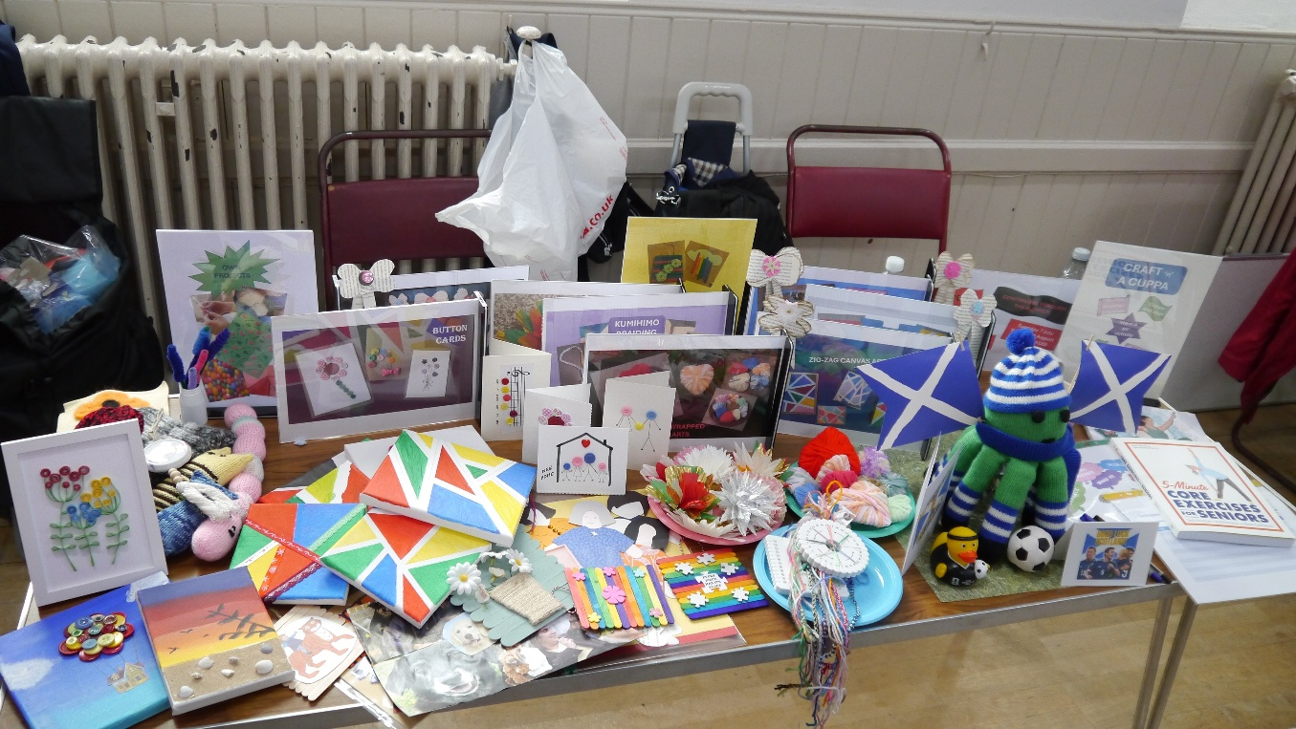
Craft n a Cuppa brought along a couple of suitcases of skilful treasures from artworks to a good luck octopus predicting he Scotland team’s success, of course, in the World Cup. There was a hands-on activity matching pictures to create a collage representing u3a.
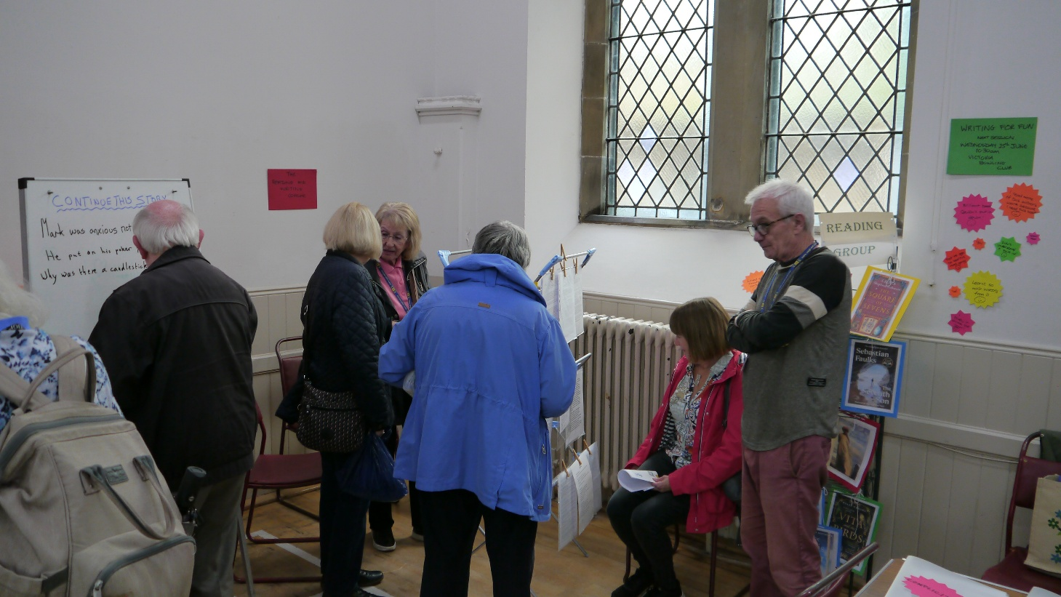
Several of the stalls had activities for visitors to try. The 3 writing and the reading group had a nook with an opportunity to sit down and read their work. A quote matching game and a continuous story on the go for people to add a line added to the interest.

The travel group is always popular and their European adventures were on show.
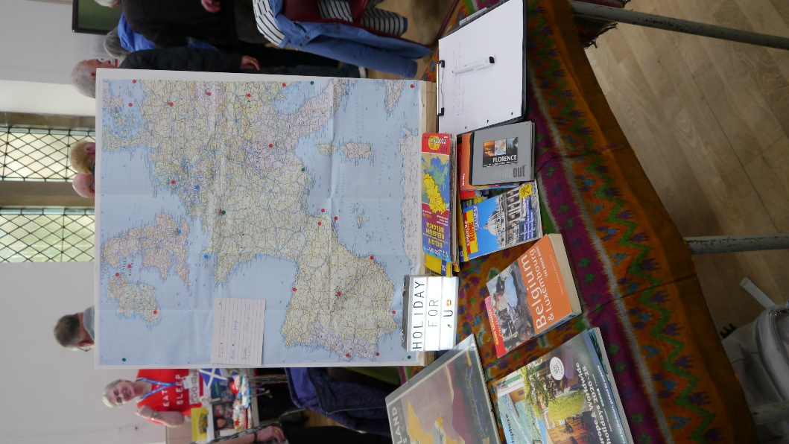

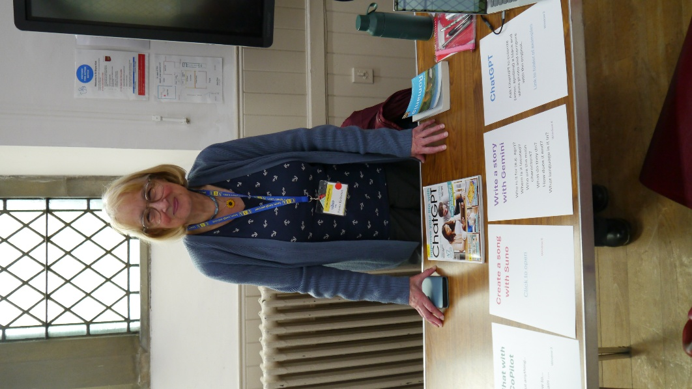
AI Explorers offered plenty of opportunity to banish technophobia. This group develops our understanding by a bit of talking but also doing to explore the world of AI and how it is involved in our lives.
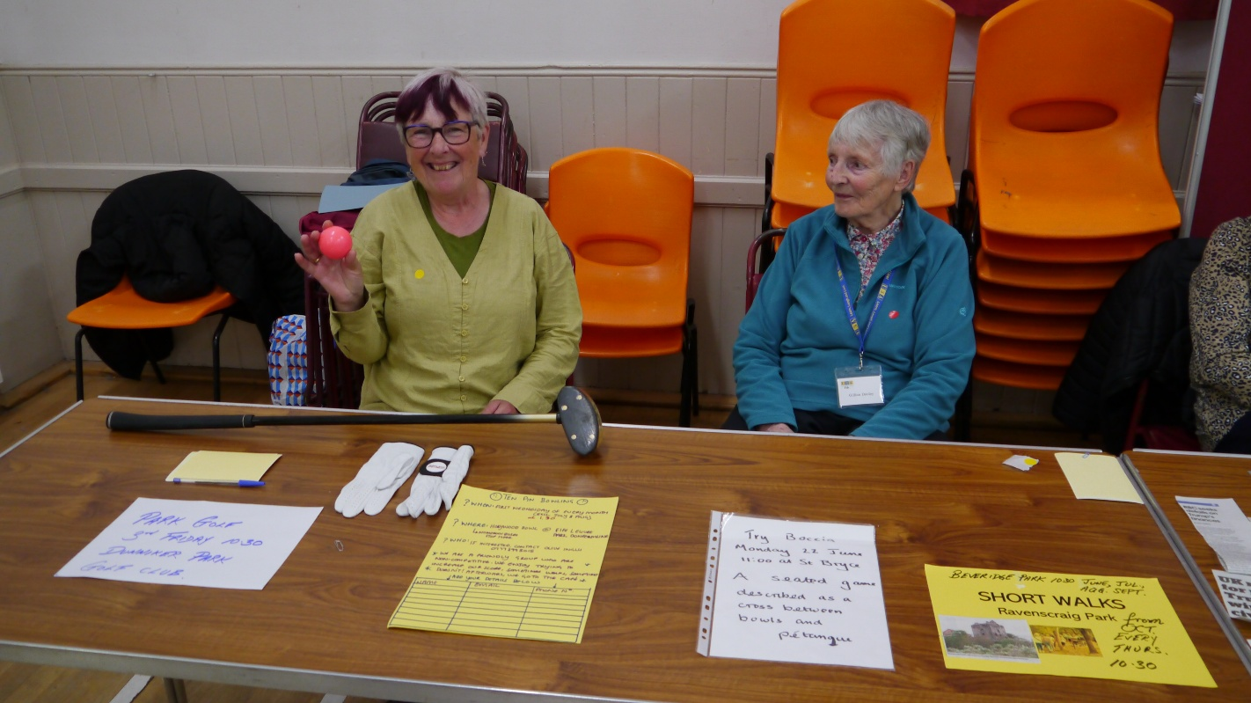
The Sports table showed us it is not just about walking groups. Park Golf, short walks, Ten Pin Bowling and the latest addition Boccia were enthusiastically represented
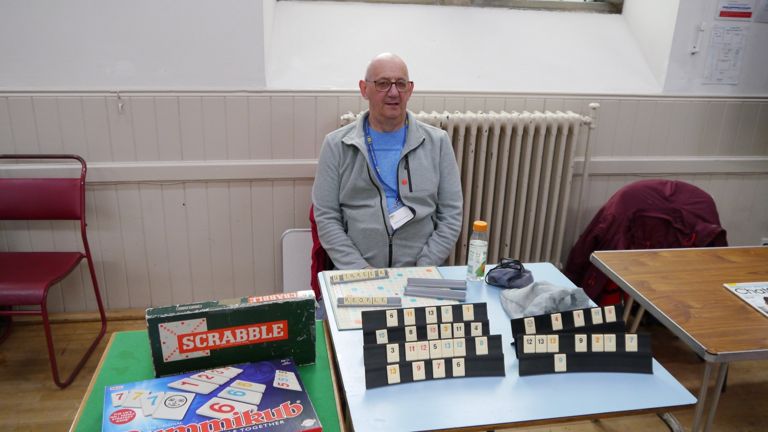
Of course, we have other kinds of games and the Games group and Backgammon group are popular. Beginners always welcome.
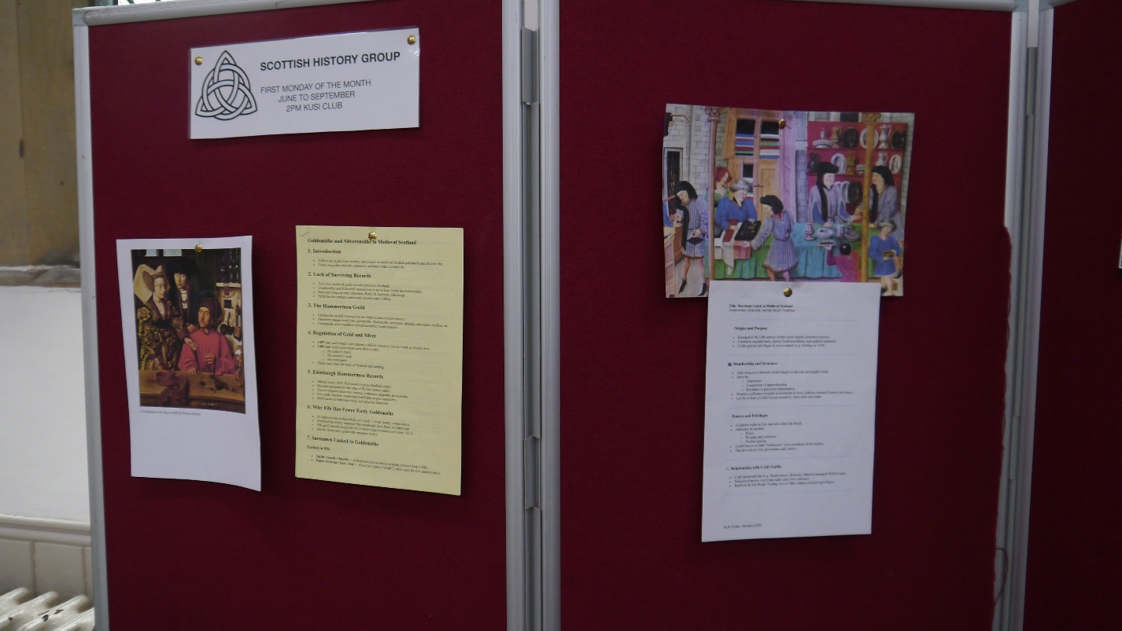

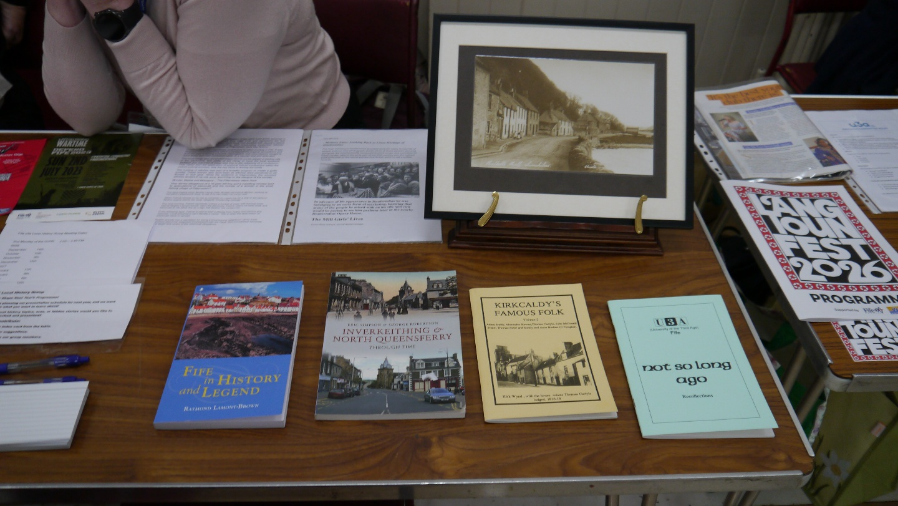
History was in the mix; Local History had an extensive display sharing space with Scottish History.

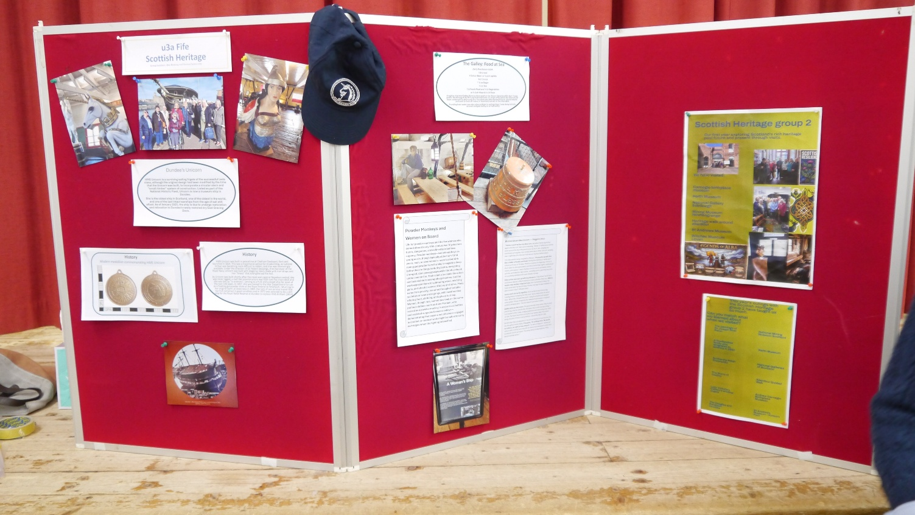
We have two Scottish Heritage Groups and they joined together to present an extensive programme of visits and talks. There were two tables of information along with the pinboard display.

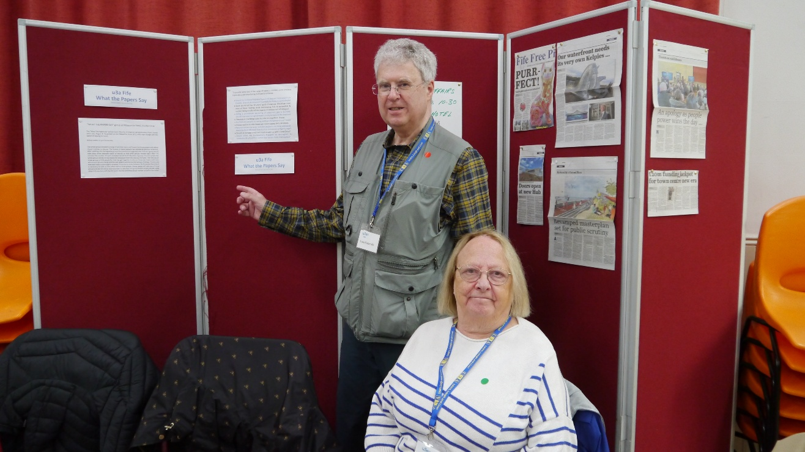
Two groups meet to discuss the News, What the Papers Say in Dunfermline and, the original, Current Affairs in Kirkcaldy. Always lively debate.

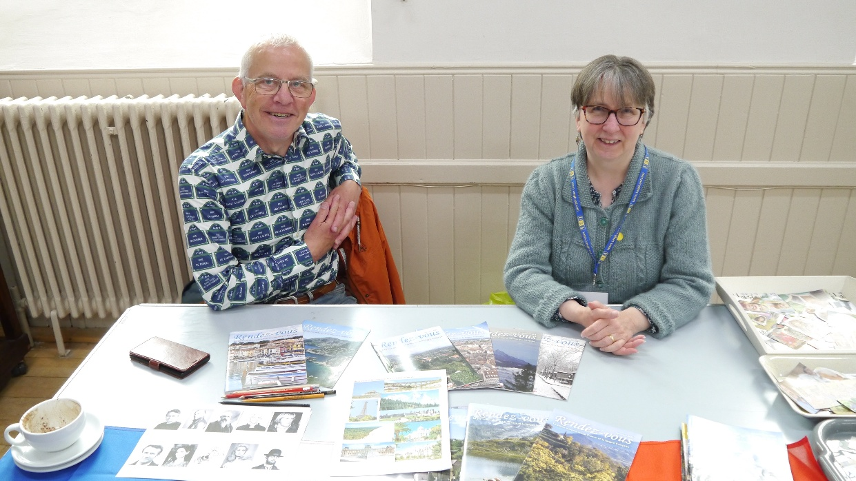
During the year we had an opportunity for foreign language practice in the form of the Spanish which is currently on pause and French. The French display included a latte, a reminder that no u3a meeting is complete without a refreshment stop.
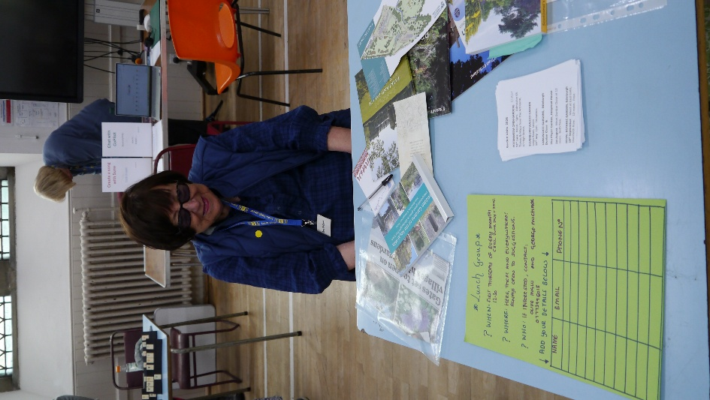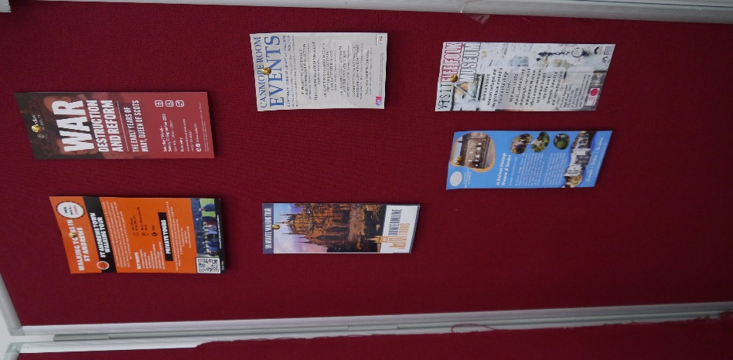
The Lunch Club, Garden Visits and Out and About have all had a busy year with visits to public and private spaces.

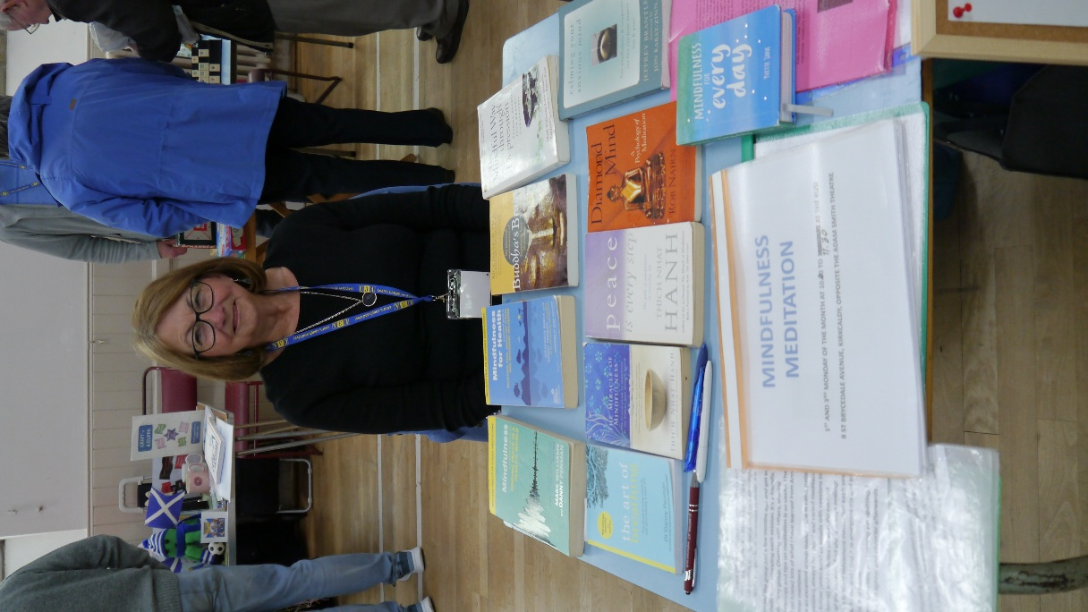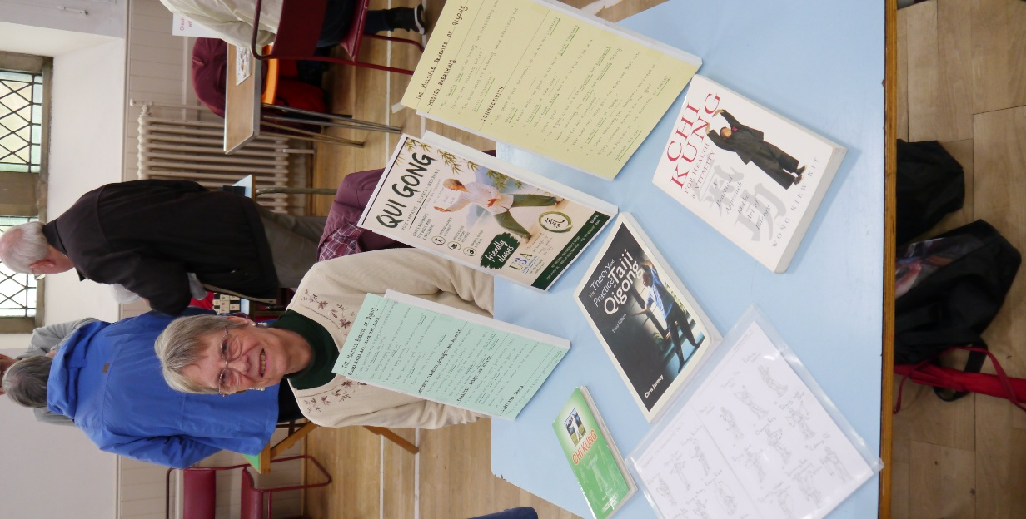

Last but not least a bit of calm in our busy lives with Meditation and Mindfulness and Qi Gong.
Unfortunately for reasons beyond their control, Art Appreciation, Quiz and Film and Theatre could not be present, which might have been a good thing as we ran out of table space. Tea and refreshments were available with a meeting room allocated this year so that people could sit and have a chat before or after their visit. Thank you to everyone who got involved and everyone who attended. I was a great afternoon and we look forward to holding it again next year.

Ruth Cross on behalf of the Committee and Promo Sub-committee.

